SP ORIENTATION TO ZOOM

Sign In
Invites
Join a Meeting
Meeting: Main View
Meeting: Participant View
Meeting: Chat View
Meeting: Share Screen
Meeting: Breakout Rooms

Sign In
via web browser, desktop application, smartphone application

Web Browser
- Go to pitt.zoom.us
- Click on “Sign In”
- You will be redirected to Pitt’s Login Screen where you will have to enter your Pitt ID and Password, followed by authentication from Duo
- From here you, will be able to see upcoming events, join a meeting, view your profile, and adjust settings

Desktop Application
- Launch Zoom
- Click “Sign In”
- Click “Sign In with SSO”
- Enter “pitt” in the “enter your company domain” so it reads “pitt.zoom.us”
- You will be redirected to Pitt’s Login Screen where you will have to enter your Pitt ID and Password, followed by authentication from Duo
- From here you, will be able to see upcoming events, join a meeting, view your profile, and adjust settings

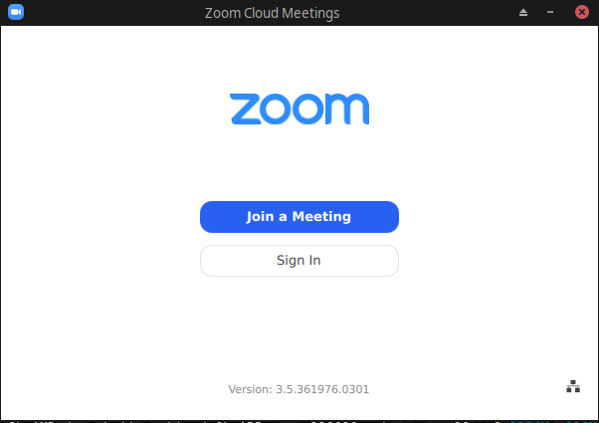

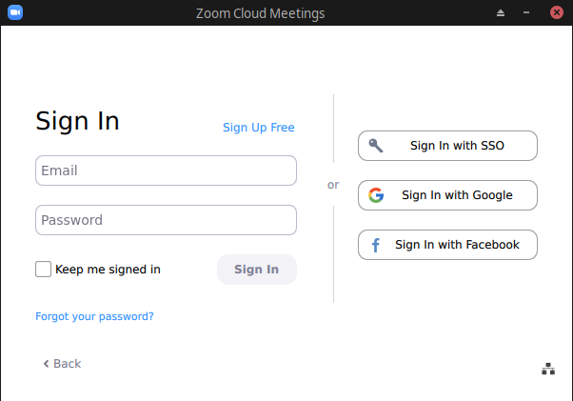

Smartphone Application
- Launch Zoom
- Press “Sign In”
- Press “SSO”
- Enter “pitt” below “enter your company domain” so it reads “pitt.zoom.us”
- You will be redirected to Pitt’s Login Screen where you will have to enter your Pitt ID and Password, followed by authentication from Duo
- From here you, will be able to see upcoming events, join a meeting, view your profile, and adjust settings

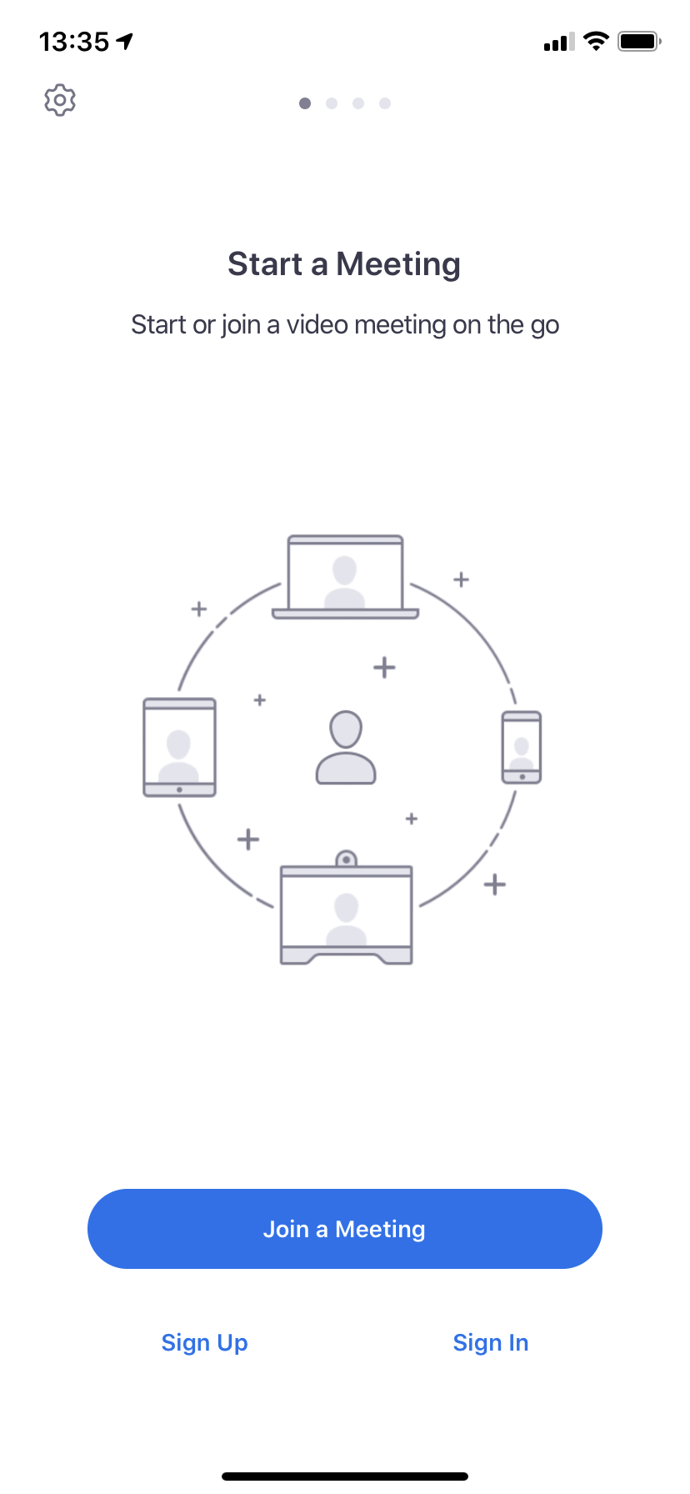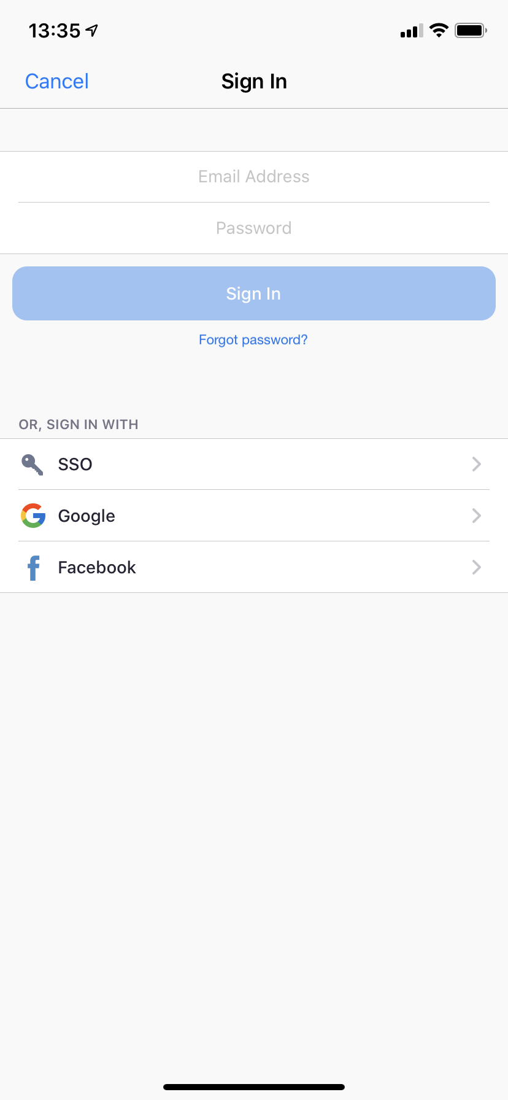

Invites
An email for an invite to a Zoom Meet usually looks like this (bolding mine):

Topic: Let’s Meet
Time: M DD, YYYY HH:MM AM/PM TIME ZONE

Join Zoom Meeting
https://pitt.zoom.us/j/123456789

Meeting ID: 123 456 789

One tap mobile
+12678310333,,123456789# US
8778535247,,123456789# US Toll-free

Dial by your location
+1 267 831 0333 US
877 853 5247 US Toll-free
Meeting ID: 123 456 789
Find your local number: https://pitt.zoom.us/u/ac1RRl39Cn

Join Zoom Meeting
- Computer or Smartphone: Click on the URL if it is active OR copy/paste the URL into a browser (computer, smartphone or tablet) to automatically join the meeting
- On the browser the URL opened in, you will be prompted to open the app if you already have it downloaded on your device
  - If you do not have the app you will be prompted to download it
- It is optional to be logged in to Zoom to attend a meeting
  - If you are logged in, the Zoom meeting will automatically open to your account with your preferred settings
  - If you are not logged in, you can choose to log in OR you can just enter a name to enter the meeting
One tap mobile
- Smartphone: Click on or call any phone number that has US at the end of the phone number to automatically join the Zoom meeting with your phone’s audio only
- ***Some invites may have more options than just the US (e.g. New York, Chicago, Houston...), ignore those; they are used for specified locations with higher Zoom traffic

Dial by your location
- Cell Phone: Call any phone number that has US at the end of the phone number to enter Zoom. Then, enter the Meeting ID, followed by the pound sign (#) to join the meeting with audio only.
- Smartphone: Click on or call any phone number that has US at the end of the phone number to enter Zoom. Then, enter the Meeting ID, followed by the pound sign (#) to join the meeting with audio only.
- ***Some invites may have more options than just the US (e.g. New York, Chicago, Houston...), ignore those; they are used for specified locations with higher Zoom traffic

Join a Meeting
via web browser - desktop application - smartphone application

For when you don’t want to use the invite, or for when you are given just the Meeting ID:

Web Browser
- Go to pitt.zoom.us
  - [Optionally] Sign in
- Click “Join” on pitt.zoom.us
  - [OR] Click “Join a Meeting” on the top right of your screen once logged in
- Enter Meeting ID Number
- The web browser will prompt you to open the Desktop Application of Zoom
  - If you do not have the Desktop Application, you will need to download it

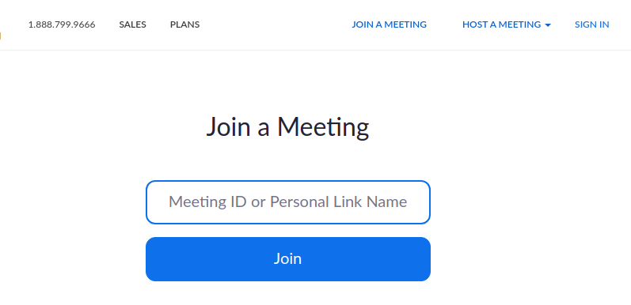

Desktop Application
- Open Zoom
  - [optionally] Sign in
- Click “Join a Meeting”
- Enter the Meeting ID
- Enter the name you would like to have displayed during the meeting (can change later)
- Click “Join”

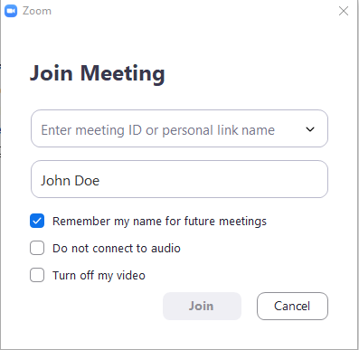

Smartphone Application
- Launch Zoom
  - [optionally] Sign in
- Press “Join a Meeting”
- Enter the Meeting ID
- Enter the name you would like to have displayed during the meeting (can change later)
- Press “Join”

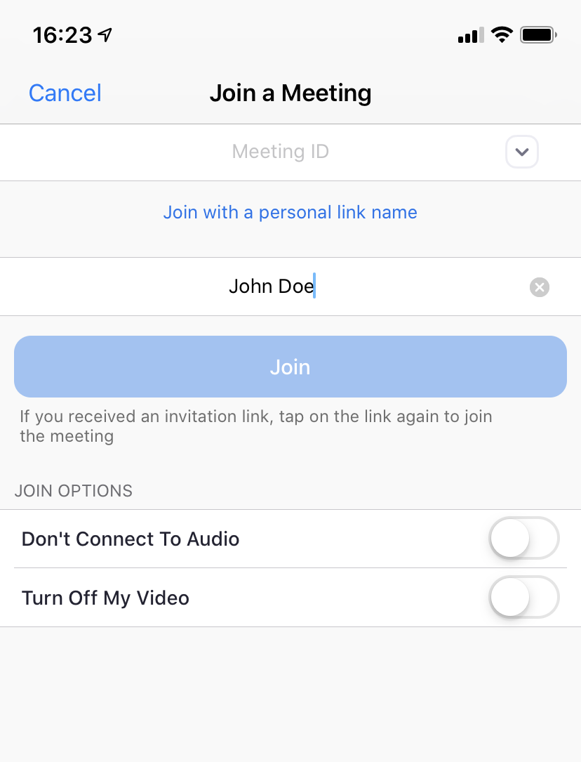

Meeting - Main View

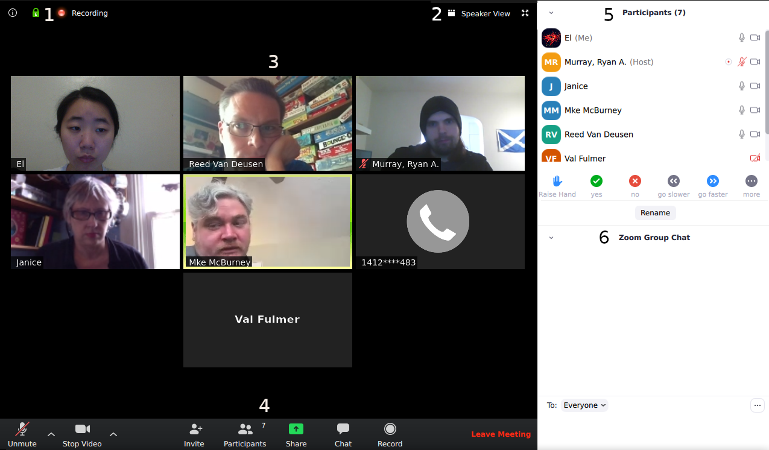

**Zoom operates on “Click on this to make it change to this” for Views, Mic, and Video**
e.g. #2 above is labelled “Speaker View”; note Gallery View is currently displayed.
One would click on #2 to change it into Speaker View.

1 - Recording Indicator
- Session is being recorded
2 – Speaker (Alt F2)/Gallery (Alt F1) View Toggle & Full/Minimize Screen Toggle (Alt F)
- Gallery View: Members are tiled on screen; if a person talks, their box is highlighted
- Speaker View: Members scroll along the top; if a person talks, their picture is enlarged
- Full Screen: Make Zoom full screen
- Minimize Screen: Shrinks Zoom so it can be moved around
3 - Main Viewing Area
- Gallery View: Shows all participants tiled across the main section of the screen
  - Shown in above example
  - Mike is talking, so his box is highlighted
- Speaker View: Shows only the participant talking on the main section of the screen
  - If the above example were in Speaker View, only Mike would be in the main section area; everyone else would be pinned horizontally to the top of the screen
4 - Bottom Bar
- Mute/Unmute (Alt A)
  - If the mic is muted/off, a red line will appear across the mic picture
- Stop/Start Video (Alt V)
  - If the camera is off, a red line will appear across the video picture
- Invite (Alt I)
  - Invite other people to the meeting
- Participants (Alt U)
  - Shows number of participants in the meeting
  - Clicking on the icon will toggle Participant View (#5)
- Share Screen (Alt S)
  - Share and annotate a chosen desktop screen, whiteboard, or mobile device
- Chat (Alt H)
  - Clicking on the icon will toggle Chat (#6 in above picture)
- Record
  - Record the meeting; the recording will either be saved locally or on the cloud
- Reactions
  - On Windows and Mac, Reactions will also be available
  - Clicking on Reactions will give an emoji option of thumbs up or clapping
  - Once selected, the reaction will appear on the upper-right corner of the participant’s box (either pinned to the top or tiled in the main section)
  - The reaction will disappear after about ten seconds
- Leave Meeting (Alt Q)
  - Self-explanatory
  - To rejoin (only possible if the Host has not ended the meeting yet), the Meeting ID will have to be re-entered
5 - Participant View
- Shows the number of participants
- Shows the names of the participants & the Host (the administrator of the meeting)
- Show audio/video status of each participant; red → mute/off
- Shows who is recording the meeting; recorders will have a red dot next to their mic
  - Participants will be notified upon entering the meeting that it is being recorded
- Gives a list of icons that can be added next to participant’s name
- Gives participants option to change their display name
6 - Chat View
- Allows text communication and file transmission to “Everyone” (all participants)
OR between individual participants

Meeting – Participant View
- Shows the number of participants
- Shows the names of the participants & the Host (the administrator of the meeting)
- Show audio/video status of each participant; red → mute/off
- Shows who is recording the meeting; recorders will have a red dot next to their mic
  - Participants will be notified upon entering the meeting that it is being recorded
- Gives a list of icons that can be added next to participant’s name
- Gives participants option to change their display name

The Icons: If pressed, the icon will appear next to the mic and camera icons on the row of the person who pressed it. These are intended for non-verbal feedback to whoever is talking.
- Raise/Lower Hand
- Yes
- No
- Go Slower
- Go Faster
PRESS “MORE”
  - Thumbs Down → Disagree
  - Thumbs Up → Agree
  - Clap → Clap
  - Coffee → Need a Break
  - Clock → Away from Computer

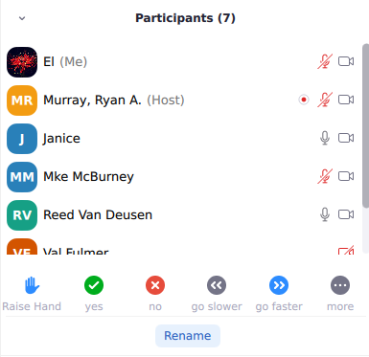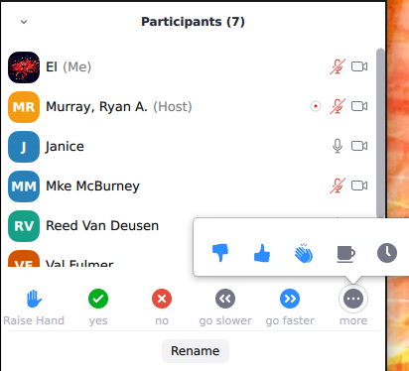

Renaming: Participants can rename themselves one of three ways.
- Hover over their current name, the name that has (Me) after it, and select “Rename”
- Underneath the icons of Participant View, click “Rename”
- In Speaker or Gallery View, hover over the upper-right corner of the box with their name or picture > Click on “…” > Click “Rename”
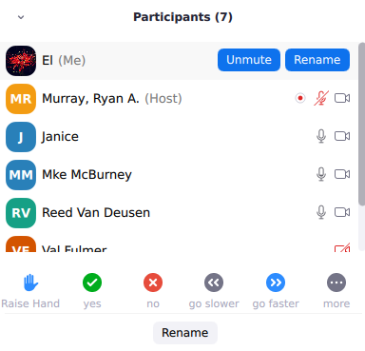

← 1

← 2

**For trainings, CHANGE TO REAL NAME
**For encounters, CHANGE TO CASE NAME

Bringing it Together: What can we tell about this Meeting from the Participant View?

- There are 7 participants
- Elizabeth has changed her name to “El” - her mic is muted, but her camera is on
- Ryan is the Host; he is recording the meeting
- Both Janice and Reed have their mic and camera on
- No one has selected an icon

Meeting – Chat View
- Allows text communication and file transmission to “Everyone” (all participants)
OR between individual participants

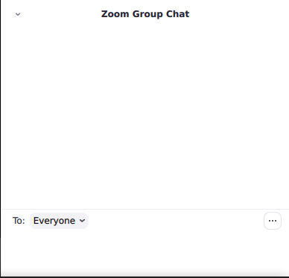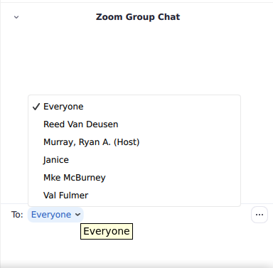

Sending a message to everyone vs Choosing who to send a private message to

… : Clicking the “…” across from “To” will allow the participant to send files to Everyone or to individual participants

Meeting – Share Screen
- Share and annotate a chosen desktop screen, whiteboard, or mobile device

- Click on “Share Screen”
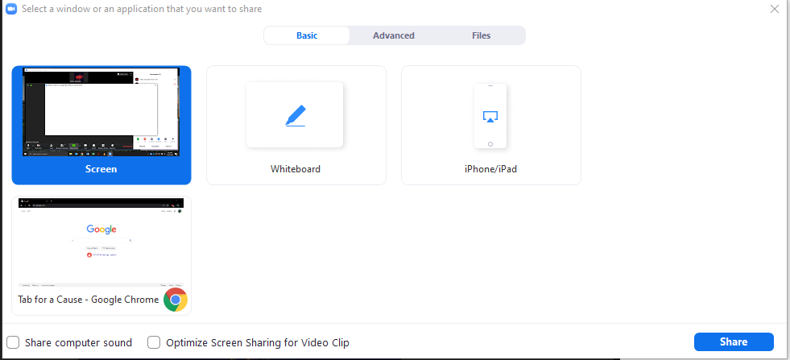

Screen Share Options
- Screen
  - Displays whatever screen is currently up and in view
  - Example: If I shared Screen with Chrome open, Chrome would be displayed. If I opened Outlook Mail over it, participants on Zoom would then see Outlook Mail
- Whiteboard
  - Creates a virtual whiteboard that can be drawn and written on
- iPhone/iPad
  - Allows the connection of an Apple Device via Screen Mirroring if the Zoom Device and the iPhone/iPad are both on the same internet network
- Individual Windows
  - Shows ONLY that particular window
  - Example: If I shared the individual window of Chrome and then opened Outlook Mail over it, participants on Zoom would still see Chrome

Meeting – Breakout Rooms
- Hosts have the option of creating “Breakout Rooms”
- Breakout rooms consist of a group of participants separated from the “Main Room”
- Hosts only have the ability to create and control breakout rooms

- When a participant is put into a breakout room, they will get a message saying:
  - “The host is inviting you to join Breakout Room: NAME OF BREAKOUT ROOM”
- Alternatively, a breakout room icon will appear in their bottom bar and they will have to click on that first before agreeing to join.
- Click “Join” to join the breakout room
- Once in the breakout room, the bottom bar gives the participant two new options

- Ask for Help
  - Tells a Host or Co-Host that help is needed in the breakout room
- Leave Breakout Room
  - Self-explanatory
  - (depending on the settings the Host uses) Allows participant to leave the breakout room and return to the main room; if the Host hasn’t closed the breakout room they’ve been assigned to, the participant who left may renter the breakout room they were assigned to

- The breakout room functions like the main room
- The Host may need to get a breakroom’s attention; to do this, they will either
  - Broadcast a text message to all of the breakout rooms
    - This will display across the top of the screen, highlighted in blue
  - Enter into individual breakout rooms

